You can use the HW device to decode the *.mov files or the encode data come from HW encode channel.

How to do the function? You can refer to the PlayDvrFCD.exe sample.
To introduce the PlayDvrFCD sample as follows:

- Initial SDK and Board
The A and B API will be first called in executing the sample.
  - sdvr_sdk_init() :
Initial driver and resource. This function should be called only once
per session.
  - sdvr_get_board_count() :
Get the installed board count in this PC.
sdvr_set_av_frame_callback() :
Register callback routine for available video frames.
sdvr_set_video_alarm_callback():
Register callback routine for video analytic alarm.

  - You must click “Init All DvrBoard” in the pop-up menu.
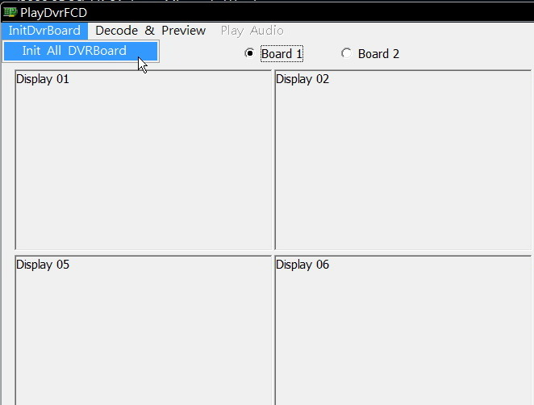

  - Select “*.rom” firmware file to upgrade.
sdvr_upgrade_firmware() :
Upgrade board firmware.
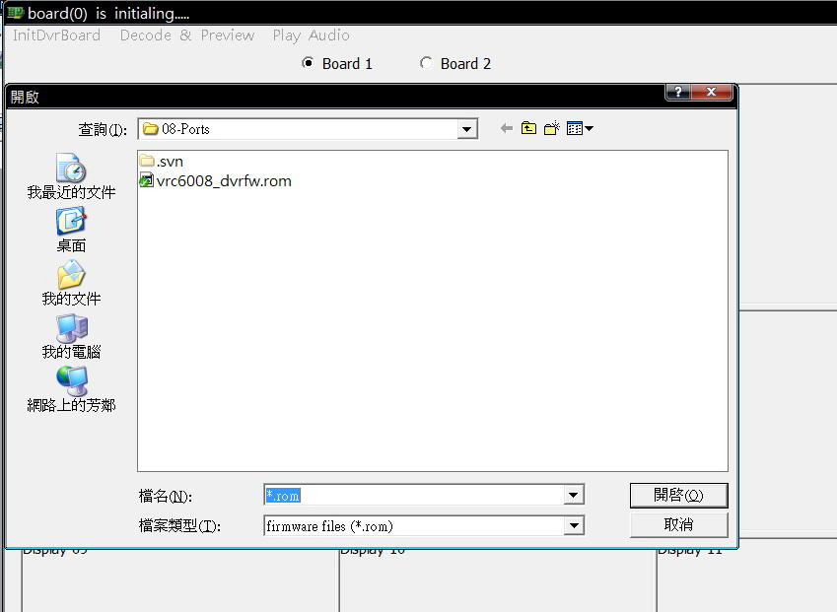

E. Get board’s config and status after upgrading the firmware.
sdvr_get_board_attributes() :
Get board’s supported video standards.
sdvr_get_sdk_params() :
Get SDK resource allocation parameters.
sdvr_get_pci_attrib() :
Get board’s PCIe attributes.
sdvr_get_board_config() :
Get installed board’s current configuration.

- Decode and Preview
The HW device can decode the *.mov files or the encode channel data.
Note:
(1) The device only can decode H.264 video format.
Don’t decode MPEG4 and MJPEG video format now.
(2) The device can’t decode the audio data now.
(3) The sample shows the HW decode function.
Do not support the SW decode function.
(4) It is important that each chip can do two decoding functions and two
encoding function. If you do over the spec. in each chip, it’s
performance will reduce. For example: frame rate reduce.

- First Click “Decode & Preview” to select channel.
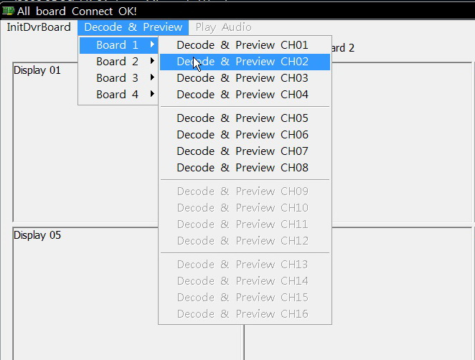

- You will see the decode setup dialog as follows:
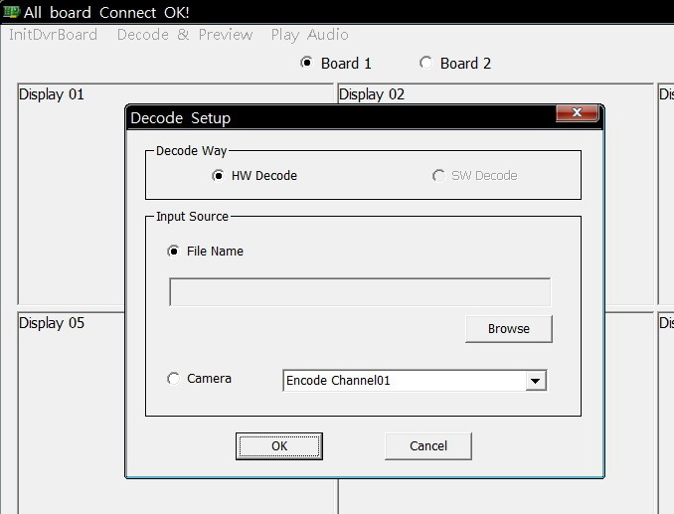

You can select the input source from the file or the encode channel to decode
(a) Select the input source: the *.mov File
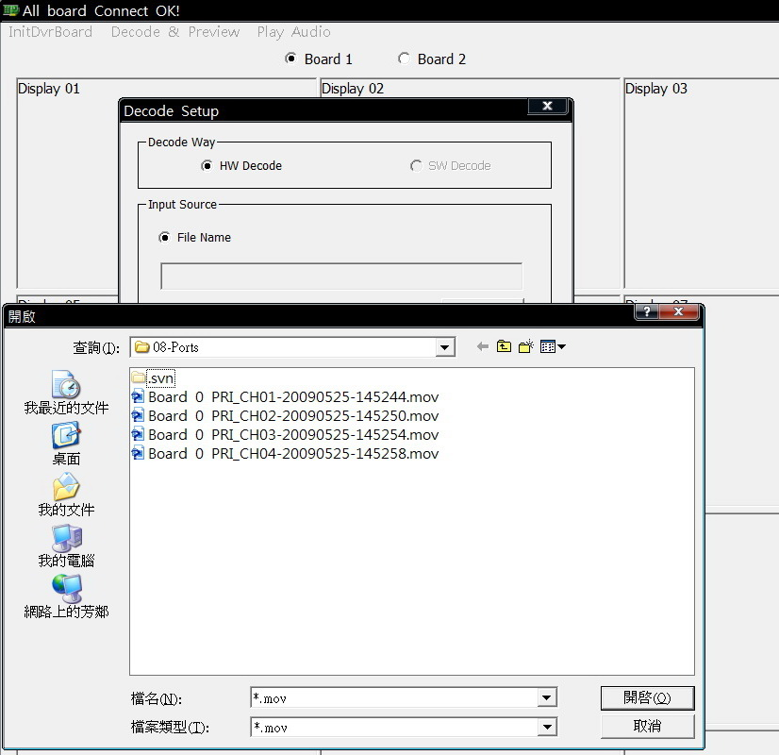

(b) Select the input source: the Encode channel
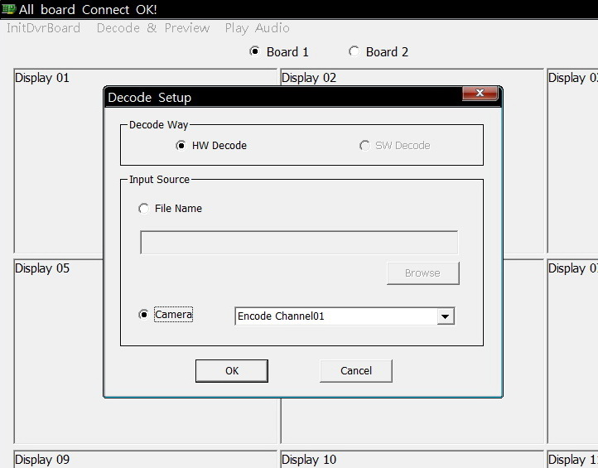

- You will see the display video as follows:
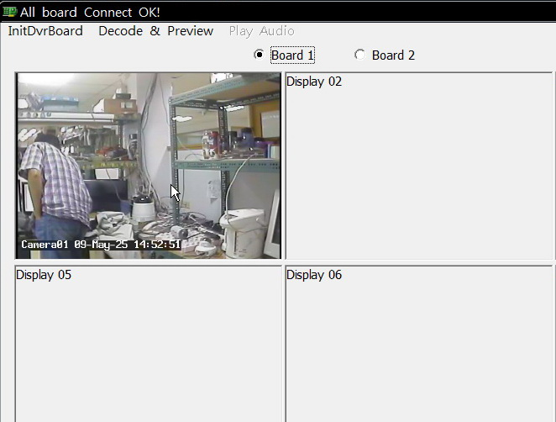
Click radio button “Board 1” ~ “Board 4” to switch the playback board channel.
(a) First create a decoding channel
sdvr_create_chan() :
Create a decoding channel.
It is important that the decoding channel must be created before the
encoding channel or loading the *.mov file.
sdvr_stream_raw_video() :
Enable or disable streaming raw video from board to host.
sdvr_stream_raw_audio() :
Enable or disable streaming raw audio from board to host.
sdvr_enable_decoder
Enable or disable the decoder for a channel

(b) Second create an encoding channel or load *.mov file
sdvr_create_chan() :
Create an encoding channel.
sdvr_enable_encoder
Enable or disable the encoder for a channel

(c) Sample will get the encoding channel’s encode video and audio data in
av_frame_callback function.
sdvr_get_av_buffer:
Get a frame of encoded video or a packet Audio for a channel
sdvr_alloc_av_buffer:
Request a free frame buffer for encoded video for board
sdvr_send_av_frame:
Send frame of encoded video to decoder on board
sdvr_release_av_frame:
Release buffer resources for reuse

- Stop Decode and Stop Preview, Close Board and Close SDK
- Stop input source
(a) An encoding channel
sdvr_enable_encoder
Enable or disable the encoder for a channel
(b) *.mov File

- Stop a decoding channel
sdvr_stream_raw_video() :
Enable or disable streaming raw video from board to host.
sdvr_stream_raw_audio() :
Enable or disable streaming raw audio from board to host.
sdvr_enable_decoder
Enable or disable the decoder for a channel

- Destroy input source
(a) sdvr_destroy_chan() :
Destroy an encoding channel
(b) Close *.mov file

D. Destroy a decoding channel
sdvr_destroy_chan() :
Destroy an encoding channel
E. Close board. Click the “InitDvrBoard 01” menu to uncheck it.
sdvr_board_disconnect() :
Disconnect from board.
F. Close SDK.
sdvr_sdk_close() :
Close SDK. Must call this function before call sdvr_sdk_init() again

